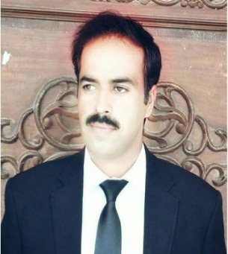
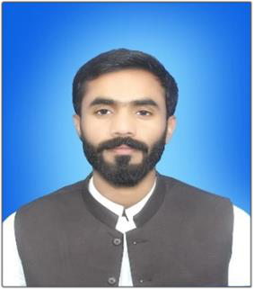SALAH-UD-DIN| Advocate

Email: advsalahuddin56@gmail.com #: 0332-2555827/0344-1144920

Personal Information

• Father’s Name: Sultan Muhammad

• CNIC: 51703-0343990-9

• Date of Birth: 18-05-1990

• Address: Siahozai Thesil Basima District Washuk

LANGUAGES

- English
- Balochi
- Urdu
- Brahvi

SKILLS

OBJECTIVE
Seeking a challenging position in a reputed organization where I can learn new skills, expand my technical knowledge, and leverage my practical earnings.

EDUCATION

 Secondary School Certificate (SSC)
Balochistan Board of Intermediate and Secondary Education Quetta

2007| Grade B

 Higher Secondary School Certificate (HSSC)
Balochistan Board of Intermediate and Secondary Education Quetta

2010 | Grade B

 BA-LLB (Hons)
Bahauddin Zakaiya University Multan Punjab

2017 | CGPA 3.89/4.00
o

• D
e f e n s
• Management Work
• Team work and Management
• Communication Skills

Other Skills

  - Legal Knowledge
  - Client Representation
  - Negotiation Skill
  - Analytical Thinking

WORK EXPERIENCES

- Advocate (Lower Court) District and Session court
(Since 2017)
- Advocate High Court
(Since 2020)

