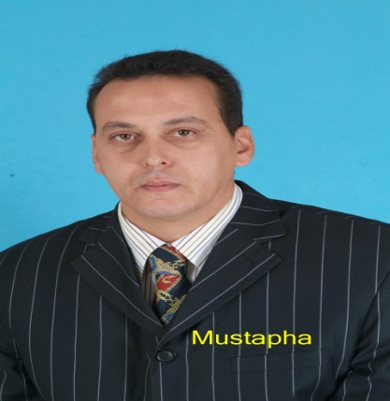
- WORK EXPERIENCE
- Captain Waiter for MARCOPOLO Hotel in Tanger1987-1988.
- Waiter for the Italian Club VALTUR in Marrakech 1997-1998.
- Cashier and Waiter for ALHAMRA Palace Restaurant in MARRAKECH.
- Accountant for Semiramis Night Club (Hotel) in Marrakech.
- Captain Waiter, Meeting Rooms Supervisor for ALFAISALIAH Hotel Riyadh/KSA 2000 to 2002
- Head waiter for SHERATON Hotel and Towers Riyadh/KSA 2002.
- Manager for ALRUMANCIYA hall in Riyadh/KSA 2003.
- F&B Supervisor for RAMADA SHROUK Hotel in Riyadh/KSA 2003.
- Captain waiter in charge of F&B operations for MARRIOTT hotel in Riyadh/KSA.2004.
- The Maître D for IMPERIAL HOLIDAY Hotel in Marrakech 2005.
- The Maître D for the opening of MOGADOR OPERA Hotel in Marrakech 2006.
- Room service Supervisor for INTERCONTINENTAL DAR TAWHID Hotel in Makkah KSA 2007.
- Assistant Head Waiter for FOUQUETS Restaurant in NAOURA BARRIERE in Marrakech 2008.
- Head Waiter for KENZI MENARA PALACE Hotel in Marrakech 2009.
- Villas Service & Butlers Supervisor for ES-SAADI Hotel in Marrakech 2010.
- Restaurant Manager for PASTA DI LUIGI Restaurant in Marrakech 2011
- Head waiter and Restaurants Supervisor for ALSHOHADA Hotel in Makkah/KSA from 2012 to 2022.
- EDUCATION AND TRAININGS

Several trainings in F&B Service, in Alfaisaliah, Intercontinental, Essaadi, Naoura Barriere hotels.

Food hygiene (HACCP), and Hospitality in DARTAWHID Hotel KSA2007
- 3 Food Safety Principles in ALSHOHADA Hôtel AND in several other hotels 2012/2018/2019.
- First aids and fire evacuation trainings in several hotels.

OPER A program for (Cashiers and Managers) in several hotels.
- F&BFIDELIO training for Operations Manager in the MARRIOTT Hôtel in KSA 2004.

Intermediate level of ENGLISH and Butler service trainings in ALFAISALIAH Hotel 2001.

Diploma in Computer Programming in PIGIER School in Marrakech 1992.
- Food service technician certificate from hospitality school in Warzazate city in Morocco.1986
- 1985: Intermediate School Certificate in SHAER ALHAMRA in Marrakech.

Name and Surname:
MUSTAPHA KOSTAS
Telephone: +212762226107
Tel +WhatsApp: +212750635927
Email: mustapha.kostas@gmail.com
Addressee : Abwab Marrakech zone 25 Imm 69A Marrakech city , MOROCCO

LANGUAGES
Speaking and writing
French: Fluent
English : Fluent
Arabic: Fluent
HOBBIES
- Reading books and web sites
- Sport (Fitness football Volleyball and Swimming)
- SKILLS
- Customer Service
- Leadership
- Team Building
- Scheduling
- Conflits Resolution
- Staff Trainings
- Time Management

